INTRODUCTION

Background
Cardiovascular diseases and diabetes remain the significant issues in health on the global basis that demand the precise, prompt, and understandable risk forecasting mechanisms. Nevertheless, clinical data is also heterogeneous, as it is composed of demographic information, lifestyle, medical history, laboratory reports and ECG signals. Conventional single-model methods are not very capable of incorporating these multimodal data, and they are not very transparent, which restricts their use in a health care setting.
This project will use an Adaptive Multi-Model Fusion Framework to offer a solution to these challenges, which will be used in intelligent and explainable risk prediction. The system starts with an effective preprocessing pipeline which involves data cleaning, feature scaling, temporal synchronization and missing value imputation to maintain data consistency and quality. Specialized predictive engines process various data modalities: TabNet works with demographic and lifestyle predictions, XGBoost with lab results and ECG, a logic module based on rules with the interpretation of structured medical history.
The products of these models are synthesized with the help of the Multimodal Transformer-based dynamic weighting mechanism, which allows cross-model interaction and adaptive attention to importance. Minor weight changes are also added with the help of clinician knowledge making sure that the domain knowledge is reflected in the prediction process.

In order to increase the level of trust and transparency, SHAP-based explainability refinement delivers comprehensive explanations of the role of features and model weights in the final decision.Another loop of clinician feedback and retraining adds further strength to the framework to improve the performance of the problem continuously due to the data upgrades and validation.
This feedback, interpretable, and adaptive architecture provides predictive accuracy as well as clinical reliability. The proposed system is an overall decision-support system of healthcare workers that will help to diagnose the patient earlier and assess his or her risk individually and better and to achieve better patient results without losing any transparency and accountability in the AI-based medical forecasting.

Problem Statement

Some of the primary and common public health issues that have a serious influence on the mortality rates in the world and particularly in developing economies such as India are cardiovascular diseases and diabetes. With the development of the medical science, in most healthcare systems, it is still difficult to detect the risks early and provide preventive care. Even in a number of clinical environments, the process of patient examination relies on individual test outcomes and physician manual interpretation, not on integrated and data-based analysis.Thus, those critical decisions that touch on risk identification, prioritization of risk treatment, and preventative strategies might not be consistent and all-inclusive

The heterogeneity and multimodality of patient data is one of the main issues in modern healthcare analytics, as patient data encompasses demographics, lifestyle trends, medical history, laboratory test results, and ECG signals. These data sources are not homogeneous in their structure, size, and time, so the process of their unified analysis is complicated.

Furthermore, the lack of high-tech predictive tools and restricted interpretability of current systems do not allow clinicians to trust AI-based proposals completely, which is a drawback between technological and clinical practice.

The current clinical decision-support systems can be characterized as being very fragmented and do not combine various forms of data into a unified predictive framework. Nonlinear relationships and cross-modal interactions of different health indicators cannot be properly modeled using many traditional models. Moreover, some of the systems do not have dynamic weighting processes and learning processes, which diminish their flexibility as time progresses. In the absence of clear explanations of methods of deriving the predictions, the high-risk patients are not easy to intervene earlier to prevent the timely diagnosis and prevention of diseases.

In order to address these drawbacks, this project suggests building an Adaptive Multi-Model Fusion Framework of heart attack and diabetes risk prediction that will benefit (or utilize) new machine learning and deep learning methods/models like XGBoost, TabNet, and logic, to work with multidimensional healthcare data. To guarantee quality and consistency of data, the system has a strong preprocessing pipeline through the following processing steps: data cleaning, feature scaling, temporal synchronization, and missing value imputation.

The structure uses TabNet to process demographic and lifestyle data, XGBoost to process laboratory reports and ECG signals, and logic to process structured medical history data. These specialized models are combined via multimodal transformer based fusion layer which allocates weights dynamically, and learns cross-model interaction to achieve better predictive performance.

The framework offers clear and faithful risk assessment by applying adaptive model fusion, clinician-feedback-based retraining, and SHAP-based explainability into a simple and easy-to-use package. This solution connects the disjunction between conventional clinical assessment and smart AI-based healthcare systems and is effective in providing precise and constantly enhancing decision assistance in the domain of forecasting the emergence of the disease.

Objectives

The main focus of the project is the construction and development of Adaptive Multi-Model Fusion Framework, which applies the best machine learning, deep learning, and explainable AI tools to help clinicians to make accurate and clear risk assessment of heart disease and diabetes. The system combines demographic, clinical, lifestyle, lab and ECG data to provide trustworthy, custom, and understandable risk profiles based on the individual patient profiles.

The first one is to examine organized clinical data including laboratory tests results and ECG signals to identify pattern related to cardiovascular diseases and diabetes. It does this through the XGBoost algorithm which is used to process high-dimensional medical data by learning probability scores on risks depending on nonlinear feature interactions. The model is also highly predictive with high-risk patients being detected early to be effectively dealt with.

The other aim is to test the demographic and lifestyle variables such as age, gender, physical activity, food habits, smoking status and family history. TabNet is used to process tabular data in an efficient manner and automatically learns the importance of features. The module would improve personalized prediction and this is because the module recognizes the influential lifestyle patterns that can contribute to the risk of disease.

An additional intention is to implement a system of logic that operates based on rules, which interprets the structured medical history information including pre-existing conditions, previous diagnoses, and medication histories. This module introduces clinical guidelines and experience into the system, and so, the domain-specific knowledge will be used to augment machine learning conclusions and enhance reliability.

The system combines the results of XGBoost, TabNet, and rule-based logic with a multimodal transformer version of fusion layer. This element dynamically assigns the adaptive weight and cross model interaction to generate the final risk score that is inclusive and balanced. The strengths of the fusion mechanism are that it enhances predicting performance because it exploits the complementary advantages of different models.

The framework also uses SHAP (SHapley Additive exPlanations) to offer clear explanations to every prediction. It underscores the input of individual features and parts of the model to overall decision, thus, enhancing clinician trust and informed medical judgment.

Last, the system will have a feedback and retraining component which will enable healthcare professionals to confirm predictions and revise model parameters when needed. This guarantees the ongoing improvement, flexibility to new medical data and compliance to the emerging clinical practice without compromising on the ease of the decision support interface.

Scope of the Project
This project will include the design, development, and implementation of an adaptive, AI-based healthcare decision-support system that will help clinicians make accurate, transparent and personalized risk predictions of heart disease and diabetes. Its system incorporates machine learning models, structured clinical data, multimodal inputs, and explainable AI methods in an effort to provide trustworthy risk evaluations and understandable insights in order to enhance medical decision process.
The framework is directly devoted to hospitals, clinics, healthcare practitioners, and medical researchers in seeking to improve early diagnosis and preventive care using smart and data-driven solutions. It takes into account a broad set of patient parameters, such as demographic data, habits, medical history, and laboratory results and ECG indicators to produce risk scores unique to the health profile of a specific patient.
In the project, XGBoost is used to analyze laboratory and ECG data, as well as to predict the probability of risk of disease and nonlinear relationships among clinical indicators. Parallel to this, TabNet will be used to process demographic and lifestyle data effectively and learn the importance of the feature dynamically. A logic module, which is rule-based, combines structured medical history and known clinical guidelines to be certain that domain knowledge is incorporated into the predictive structure.In a bid to improve the overall performance and reliability, the system employs a multimodal transformer based fusion mechanism that dynamically allocates adaptive weights to outputs of various predictive models.
This allows interaction of cross models and scoring of risks in a balanced manner. Moreover, SHAP-based explainability has been implemented to give insightful information regarding feature contribution and model decisions to enhance transparency and trust between a clinician and a model.
The framework is effective in the different patient groups and healthcare environments by incorporating predictive modeling, adaptive fusion, explainable AI, and clinician feedback. It enables medical practitioners with practical insight that allows them to identify cases early, help them to reduce diagnostic uncertainty and optimize patient outcomes in the long term with dependable and understandable AI-based analytics.

Significance of the Project
Heart diseases and diabetes are very serious reasons of mortality rates in the world and are challenging health care services even in the developing world since access to early diagnostic equipment may be scarce. Much of the population does not know their risk status until complications set in whichby their health status results in severe outcomes and high treatment costs. These issues require creative and smart solutions that can help clinicians to detect the problem early, provide preventive care, as well as risk assessment on an individual level.
These problems can be mitigated through the proposed Adaptive Multi Model Fusion Framework which proposes a data driven, AI powered framework that can assist healthcare professionals in making accurate and timely clinical decisions. Using the state of the art machine learning and deep learning models namely XGBoost, TabNet, rule based logic, and transformer based fusion, the system makes sound risk forecasts with a better level of interpretability.
XGBoost is used to process structured clinical data: lab reports and ECG data to produce risk probability scores and predict the severity of the possible cardiovascular or diabetic disorder. This will enable the clinicians to have a quantitative understanding of the risk they will allow them to prioritize the high risk patients and prescribe preventive interventions efficiently. The forecasting ability improves an early diagnosis and minimizes the chances of unexpected health disasters.
TabNet is also used to assess the demographic and lifestyle variables including age, physical activity, dietary habits, smoking status and family history. However, with dynamically learning importance of features, the system can determine the key contributors of behavioral and environmental risks. This facilitates individual healthcare planning and promotes healthier lifestyle changes among patients on the basis of data driven evidence.
Rule based logic has also been infused in the system to understand the structured medical history and incorporate in the prediction process well defined clinical guidelines. Transformer based fusion mechanism is a mechanism that incorporates the output of various models and it dynamically applies weights to achieve balanced and comprehensive risk measurement. Also, SHAP based explainability improves transparency because it visually shows the contribution that each feature makes to the overall prediction, which empowers clinicians with trust and responsibility.
More broadly, this project contributes to the trend in the world in favor of precision medicine, preventive healthcare, and AI driven clinical innovation. With predictive analytics and explainable AI coupled with adaptive multi model fusion, the framework will foster an improved, more accurate, and patient-centered healthcare ecosystem that can decrease disease burden and enhance long-term health outcomes.

LITERATURE REVIEW
Arman et al. [1] introduced an explainable self-supervised learning framework for heart disease prediction, leveraging the EDA–SimCLR–SHAP pipeline. Their approach combined Exploratory Data Analysis (EDA) for preprocessing and feature exploration, SimCLR (Simple Contrastive Learning of Representations) for self-supervised deep representation learning, and SHAP (SHapley Additive exPlanations) for interpretability. The framework employed Deep Neural Networks (DNNs) trained with SimCLR embeddings, alongside comparative baselines such as Logistic Regression, Random Forest, and Gradient Boosting (XGBoost). Results demonstrated that the selfsupervised SimCLR-based model achieved superior accuracy and generalizability, particularly in scenarios with limited labeled data. The SHAP-based interpretability ensured transparency, making the framework clinically trustworthy. This work supports the concept of our project by showing how self-supervised learning combined with explainable AI can enhance predictive precision and interpretability in cardiovascular risk assessment.
Dou and Liu [2] focused on the application of interpretable machine learning algorithms for the diagnostic prediction of diabetic retinopathy. Their study employed models such as Logistic Regression, Random Forest, Gradient Boosting (XGBoost), Support Vector Machines (SVM), and Convolutional Neural Networks (CNNs). To ensure clinical trust, they integrated interpretability frameworks including SHAP (SHapley Additive exPlanations) and LIME (Local Interpretable Model-Agnostic Explanations), which provided transparency into feature contributions such as retinal imaging parameters, patient demographics, and clinical biomarkers.
Results demonstrated that ensemble and boosting methods achieved strong predictive accuracy, while CNNs excelled in image-based feature extraction. Importantly, the interpretability tools allowed clinicians to validate predictions and understand risk factors, bridging the gap between AI performance and medical usability. This work supports the concept of our project by showing how interpretable machine learning combined with imaging and clinical data can enhance precision and trustworthiness in diabetic retinopathy risk prediction.
Dzakiyullah et al. [3] presented a multi-label machine learning framework for predicting diabetes-related complications. Their study employed algorithms such as Random Forest, Support Vector Machines (SVM), k-Nearest Neighbors (k-NN), Decision Trees, and Gradient Boosting (XGBoost) to classify multiple complication risks simultaneously, including neuropathy, retinopathy, and cardiovascular issues. The multi-label approach allowed the system to handle overlapping outcomes, reflecting the complex nature of diabetes progression. Results demonstrated that ensemble and treebased methods achieved superior accuracy and sensitivity compared to traditional single-output classifiers. Furthermore, the research emphasizes the importance of multi-label modeling in healthcare, as patients often face multiple concurrent risks rather than isolated conditions. This work supports the concept of our project by showing how multi-model and multi-label learning can enhance predictive precision in chronic disease management, particularly for diabetes complications.

Fu et al. [4] presented an ensemble-based multi-model learning framework designed to predict hospitalization patterns among cardiovascular patients and provide early warnings during pandemic conditions. Their study employed a diverse set of algorithms including Random Forest, Gradient Boosting Machines (GBM), Support Vector Machines (SVM), Logistic Regression, and Deep Neural Networks, which were integrated into an ensemble structure to capture complex temporal and clinical relationships. This integration allowed the system to leverage complementary strengths of individual models, improving robustness and generalizability across heterogeneous patient datasets. Results demonstrated that ensemble learning significantly enhanced predictive accuracy and resilience compared to single-model approaches, validated through external cohorts. Furthermore, the research emphasizes the importance of multi-source integration and external validation in healthcare analytics. This work supports the concept of our project by showing how adaptive multi-model fusion can enhance predictive precision and resilience in medical risk prediction systems.
Gul et al. [5] presented a systematic review of machine learning and ensemble methods applied to cardiovascular disease prediction. Their study analyzed a wide range of algorithms including Logistic Regression, Decision Trees, Random Forest, Support Vector Machines (SVM), Gradient Boosting (XGBoost, LightGBM), k-Nearest Neighbors (k-NN), and Deep Neural Networks, as well as ensemble strategies that combine multiple models for improved robustness. The review highlights performance trends across different datasets, noting that ensemble approaches consistently outperform single-model methods in terms of accuracy, sensitivity, and specificity. Results also emphasize the importance of explainability and clinical trust, pointing out challenges such as data imbalance, interpretability, and generalizability across populations.
Jain et al. [6] presented a multi-model ensemble learning framework to investigate the impact of gender and age variability in diabetes prediction. Their study employed a diverse set of algorithms including Logistic Regression, Random Forest, Support Vector Machines (SVM), Gradient Boosting, and Neural Networks, which were combined in an ensemble structure to capture complementary strengths across models. This integration allowed the system to account for demographic variability and improve robustness in predictive outcomes. Results demonstrated that incorporating gender and age factors significantly enhanced predictive accuracy compared to uniform models. Furthermore, the research emphasizes fairness and inclusivity in medical AI, ensuring reliable performance across heterogeneous patient subgroups. This work supports the concept of our project by showing how adaptive multi-model fusion can incorporate demographic diversity and algorithmic complementarity to improve precision in diabetes risk prediction.
Li et al. [7] conducted a multicenter study applying artificial intelligence models to predict the risk of diabetic foot complications. Their framework employed a diverse set of algorithms including Logistic Regression, Random Forest, Gradient Boosting (XGBoost), Support Vector Machines (SVM), and Deep Neural Networks (DNNs). By integrating patient demographic data, clinical records, and laboratory results, the models were trained to identify high-risk individuals across multiple hospital cohorts. Results demonstrated that ensemble and boosting methods achieved superior predictive accuracy and generalizability compared to traditional single classifiers. The study also emphasized the importance of multicenter validation to ensure robustness across heterogeneous populations. Furthermore, the research highlights the clinical utility of AI-driven risk prediction in preventive care, enabling early interventions to reduce severe diabetic foot outcomes.
This work supports the concept of our project by showing how multi-model AI frameworks validated across diverse cohorts can enhance precision and reliability in chronic disease complication prediction.
Lin and Fan [8] proposed the FMI-CAECD framework, which fuses multi-input convolutional features with an enhanced channel attention mechanism for cardiovascular disease prediction. Their study employed Convolutional Neural Networks (CNNs) as the primary architecture, designed to process multiple heterogeneous inputs such as clinical records, imaging data, and physiological signals. The enhanced channel attention module dynamically weighted feature maps, ensuring that the most relevant signals were emphasized during prediction. Comparative experiments against traditional models such as Logistic Regression, Random Forest, Support Vector Machines (SVM), and Gradient Boosting (XGBoost) demonstrated that FMI-CAECD achieved superior accuracy, sensitivity, and robustness across diverse datasets. Results highlighted that multi-input fusion combined with attention mechanisms significantly improved generalizability and interpretability. This work supports the concept of our project by showing how deep learning with channel attention and multi-input fusion can strengthen predictive precision in cardiovascular risk assessment.
Menshawi et al. [9] proposed a hybrid generic framework for heart problem diagnosis that integrates multiple machine learning paradigms to improve predictive accuracy and generalizability. Their study employed algorithms such as Logistic Regression, Decision Trees, Random Forest, Support Vector Machines (SVM), k-Nearest Neighbors (k-NN), and Gradient Boosting (XGBoost). The hybrid framework combined statistical learning models with ensemble strategies, enabling robust classification of heart disease risk factors across diverse datasets.
Results demonstrated that hybridization improved sensitivity and specificity compared to standalone models, particularly in handling heterogeneous patient data. Furthermore, the research emphasizes the importance of flexible, generic frameworks that can adapt to different clinical contexts while maintaining high diagnostic reliability. This work supports the concept of our project by showing how hybrid machine learning paradigms can strengthen predictive precision and scalability in cardiovascular risk assessment.
Muhyi and Ata [10] presented a comparative study of integrative machine learning approaches for cardiovascular disease prediction, focusing on Extreme Gradient Boosting (XGBoost) and Adaptive Neuro-Fuzzy Inference System (ANFIS) algorithms. Their framework evaluated the strengths of both methods: XGBoost for handling structured clinical data with high accuracy and scalability, and ANFIS for capturing nonlinear relationships through fuzzy logic and neural learning. By integrating these approaches, the study demonstrated improved predictive performance and interpretability compared to using either algorithm alone. Results highlighted that hybridization of statistical learning and neuro-fuzzy systems enhances robustness in medical risk prediction. Furthermore, the research emphasizes the importance of combining rule-based interpretability with advanced machine learning for clinical trust. This work supports the concept of our project by showing how multi-model fusion across diverse algorithmic paradigms can improve precision and transparency in cardiovascular risk assessment.

Rao et al. [11] presented a stacked ensemble learning framework for heart disease prediction, enhanced with SMOTE (Synthetic Minority Oversampling Technique) to address class imbalance in medical datasets. Their study employed base algorithms such as Logistic Regression, Decision Trees, Random Forest, Support Vector Machines (SVM), and Gradient Boosting (XGBoost), which were stacked into a meta-model to combine their predictive strengths. The SMOTE technique was used to generate synthetic samples of minority classes, ensuring balanced training and reducing bias in predictions. Results demonstrated that the stacked ensemble achieved superior accuracy, sensitivity, and F1-scores compared to single classifiers and traditional ensembles without oversampling. Furthermore, the research emphasizes the importance of handling imbalanced data in healthcare applications to improve reliability and fairness. This work supports the concept of our project by showing how stacked ensembles combined with data balancing techniques can enhance predictive precision in cardiovascular risk assessment.
Ritika et al. [12] presented a multi-phase framework for heart disease diagnosis and management that integrates deep learning models with personalized nutrition strategies. Their study employed algorithms such as Convolutional Neural Networks (CNNs), Recurrent Neural Networks (RNNs), and Deep Feedforward Neural Networks (DNNs) to analyze clinical data, lifestyle factors, and dietary patterns. The framework operates in multiple phases: initial risk detection using deep learning classifiers, patient-specific management recommendations through nutritional analysis, and iterative refinement based on feedback loops. Results demonstrated that combining medical data with personalized nutrition significantly improved diagnostic accuracy and patient outcomes compared to conventional approaches. Furthermore, the research emphasizes the importance of holistic healthcare models that merge AI-driven diagnostics with lifestyle interventions.
This work supports the concept of our project by showing how multimodel deep learning combined with contextual factors (like nutrition) can enhance precision and personalization in cardiovascular risk prediction and management.
Shaheen et al. [13] introduced a privacy-conscious framework for early diabetes prediction that leverages Deep Residual Networks (ResNets) combined with proximitybased data analysis techniques. Their approach emphasizes both predictive accuracy and patient data confidentiality, integrating advanced deep learning with privacypreserving mechanisms. The ResNet architecture was employed to capture complex nonlinear relationships in patient health records, while proximity-based methods ensured secure handling of sensitive data by minimizing direct exposure of raw patient information. Results demonstrated that the framework achieved superior accuracy and robustness compared to traditional machine learning models such as Logistic Regression, Random Forest, and Support Vector Machines (SVM), while also maintaining strong privacy guarantees. Furthermore, the research highlights the importance of balancing predictive performance with ethical considerations in medical AI. This work supports the concept of our project by showing how deep learning models like ResNet can be fused with privacy-aware strategies to deliver trustworthy and clinically applicable diabetes risk prediction systems.
Singh and Tiwari [14] presented a comprehensive machine learning framework for early detection of diabetes, specifically addressing challenges of imbalanced datasets, missing values, and outlier handling. Their study employed algorithms such as Logistic Regression, Random Forest, Support Vector Machines (SVM), Gradient Boosting (XGBoost), and Artificial Neural Networks (ANN). To improve reliability, they integrated preprocessing techniques including SMOTE (Synthetic Minority Oversampling Technique) for class imbalance, data imputation methods for missing values, and robust scaling/outlier detection to minimize noise.
Results demonstrated that ensemble and boosting methods achieved superior accuracy and sensitivity compared to traditional classifiers, particularly when combined with advanced preprocessing. Furthermore, the research emphasizes the importance of handling realworld data imperfections to ensure clinical applicability. This work supports the concept of our project by showing how adaptive multi-model fusion, combined with preprocessing strategies, can enhance predictive precision in diabetes risk assessment under challenging data conditions.
Talukder et al. [15] introduced XAI-HD, an explainable artificial intelligence framework for heart disease detection that integrates predictive modeling with interpretability mechanisms. Their study employed algorithms such as Logistic Regression, Random Forest, Gradient Boosting (XGBoost), Support Vector Machines (SVM), and Deep Neural Networks (DNNs). The framework incorporated SHAP (SHapley Additive exPlanations) and LIME (Local Interpretable Model-Agnostic Explanations) to provide transparency into model decisions, enabling clinicians to understand the contribution of individual features (e.g., age, cholesterol, blood pressure) to risk predictions. Results demonstrated that ensemble and boosting methods achieved superior predictive accuracy, while the integration of XAI tools enhanced trustworthiness and clinical applicability. Furthermore, the research emphasizes the importance of explainability in medical AI, ensuring that highperforming models remain interpretable and ethically aligned with healthcare needs. This work supports the concept of our project by showing how multi-model fusion combined with XAI frameworks can deliver both precision and transparency in cardiovascular risk prediction.

Usha and Rajalakshmi [16] presented a confidence-calibrated adaptive weighting framework that integrates multiple machine learning models for diabetes diagnosis. Their study employed algorithms such as Logistic Regression, Random Forest, Gradient Boosting (XGBoost), Support Vector Machines (SVM), and Artificial Neural Networks, which were combined into a multi-model ensemble. The adaptive weighting mechanism dynamically adjusted the contribution of each model based on confidence scores, ensuring that predictions remained both accurate and reliable across diverse patient datasets. Results demonstrated that this ensemble approach significantly improved diagnostic precision compared to static weighting or single-model baselines. Furthermore, the research emphasizes the importance of confidence calibration in medical AI, enhancing trustworthiness and clinical applicability. This work supports the concept of our project by showing how adaptive multi-model fusion with explainability can strengthen risk prediction in diabetes and related health conditions.
Yuan et al. [17] presented a dynamic weighted ensemble learning framework for cardiovascular risk prediction in patients with type 2 diabetes. Their study employed multiple algorithms including Logistic Regression, Random Forest, Gradient Boosting (XGBoost, LightGBM), Support Vector Machines (SVM), and Deep Neural Networks (DNN). The framework dynamically adjusted the contribution of each model based on performance metrics, ensuring that the ensemble remained adaptive to varying patient data distributions. To enhance clinical trust, the study integrated SHAP (SHapley Additive exPlanations) for interpretability, allowing clinicians to understand the feature importance and contribution of each model to the final risk prediction. Results demonstrated that the dynamic weighted ensemble achieved superior accuracy, sensitivity, and generalizability compared to static ensembles and single-model baselines.
Furthermore, the research emphasizes the importance of combining adaptive weighting with explainable AI for reliable medical decision support. This work supports the concept of our project by showing how multi-model fusion with SHAPbased interpretability can improve precision and transparency in cardiovascular risk prediction for diabetic patients.
Yu and Chen [18] presented a fusion-based framework that integrates machine learning algorithms with medical imaging techniques to enhance cardiac disease detection. Their study employed algorithms such as Support Vector Machines (SVM), Random Forest, Gradient Boosting (XGBoost), and Convolutional Neural Networks (CNNs). The framework combined structured patient data (clinical and demographic information) with imaging features extracted from echocardiograms and MRI scans, enabling a multimodal approach to diagnosis. Results demonstrated that the fusion of imaging and non-imaging data significantly improved predictive accuracy, sensitivity, and specificity compared to models relying on a single data source. Furthermore, the research emphasizes the importance of multimodal integration in healthcare, showing that combining imaging with machine learning provides a more holistic and reliable diagnostic tool. This work supports the concept of our project by illustrating how multimodel fusion across diverse modalities can strengthen precision and clinical trust in cardiac risk prediction.
Zedadra et al. [19] proposed a graph-aware multimodal deep learning framework for the classification of diabetic retinopathy images. Their approach integrated Convolutional Neural Networks (CNNs) for image feature extraction with Graph Neural Networks (GNNs) to model relational dependencies among multimodal data sources, such as retinal imaging, patient demographics, and clinical biomarkers.
By combining CNN-based visual features with graph-aware representations, the framework captured both local image-level patterns and global inter-patient relationships. Comparative experiments against traditional models such as Logistic Regression, Random Forest, Support Vector Machines (SVM), and Gradient Boosting (XGBoost) demonstrated that the multimodal graph-aware approach achieved superior accuracy, sensitivity, and interpretability. Results highlighted that incorporating graph structures into multimodal deep learning significantly improved generalizability across diverse datasets. This work supports the concept of our project by showing how graph- aware multimodal fusion can enhance predictive precision and clinical trust in diabetic retinopathy diagnosis.
Zhuang et al. [20] presented a hybrid framework that integrates Convolutional Neural Networks (CNNs) with ensemble learning methods to enhance diabetes diagnosis across multiple datasets. Their study employed CNNs for feature extraction from structured and semi-structured patient data, while ensemble algorithms such as Random Forest, Gradient Boosting (XGBoost, LightGBM), and Support Vector Machines (SVM) were used to combine predictive outputs. The multi-dataset evaluation demonstrated that the hybrid CNN–ensemble approach achieved superior accuracy, sensitivity, and generalizability compared to standalone models. Results highlighted that CNNs effectively captured complex feature representations, while ensemble methods improved robustness and reduced overfitting. Furthermore, the research emphasizes the importance of integrating deep learning with ensemble strategies to handle heterogeneous medical data. This work supports the concept of our project by showing how multimodal fusion of deep learning and ensemble techniques can improve predictive precision in diabetes risk assessment.

CHAPTER 1

EXISTING AND PROPOSED APPROACH

Existing Techniques for Disease Prediction
Some of the machine learning and deep learning algorithms have been popularly applied in past years to predict chronic diseases like cardiovascular disorders and diabetes. Such methods are meant to examine patient records and come up with trends that are likely to point to disease occurrence. The widely employed methods consist of conventional machine learning methods, deep learning, and ensemble methods.
Conventional machine learning models like the Logistic Regression, Decision Trees, Random Forest, Support Vector Machines, Naive Bayes and K-Nearest Neighbors have been widely used with healthcare prediction systems. These models mostly operate on organized data like patient demographics and laboratory outcomes and clinical measurements. They can determine the connections among input features and disease outcomes, which can be used to predict disease at its early stages.
Over the past few years, the popularity of deep learning models, including Convolutional Neural Networks (CNNs) and Deep Neural Networks (DNNs), has increased because of their capability to learn complicated patterns with large amounts of data. Such models come in handy especially when handling unstructured information like medical images and ECG signals. Enhanced, moreover, ensemble learning approaches involve a combination of several models that are used to enhance the accuracy and strength of prediction.

Even though these techniques have played a critical role in disease prediction, they are in most cases tailored to handle a particular kind of data and are not effective in combining different sources of data. This weakness decreases their effectiveness in tackling real-life healthcare events which data is extremely heterogeneous.

1.2 Advantages of Existing Techniques

The available machine learning and deep learning solutions have a number of advantages that have seen them gain popularity in health care systems:

Machine learning applications are used to predict the disease avoiding clinicians to perform the manual analysis. This assists in quick diagnosis and enables the medical care giver to make prompt decisions particularly in some severe cases such as heart attacks and diabetes.

These techniques can handle high amounts of patient records, both clinical and laboratory records. The ability allows the observation of undetectable patterns and relationships that are hard to identify through the conventional means.

Random Forest and XGBoost algorithms are quite accurate (they use a combination of decision trees and take into account the interaction of features). This renders them useful in predicting illnesses using the structured clinical parameters.

Deep learning models, in particular advanced ones, are capable of nonlinear modeling of different health factors. This enhances the quality of predictions and enables better comprehension of patterns of diseases.

Disadvantages of Existing Techniques

Despite their advantages, existing techniques have several limitations that affect their performance in real-world healthcare applications. The major disadvantages are:

The majority of the models that are currently developed are targeting only structured data like numerical clinical values. They do not combine various types of data, such as lifestyle choices and ECG indications, which would result in the partial analysis and low accuracy of predictions.

A lot of the developed models, especially deep learning methods lack explanations of the predictions. This renders the findings not very reliable and makes the findings less applicable to actual healthcare settings by the clinicians.

Old models are not dynamically adjusted to new patient data and evolving medical conditions. After their training, they are fixed and this limits their applicability in changing healthcare settings.

There are those models that are likely to work well on training data, but not on new and unknown data. This problem of overfitting is related to the reliability of prediction in limited or imbalanced data sets.

Proposed System: Adaptive Multi-Model Fusion Framework.
This project will use the Adaptive Multi-Model Fusion Framework to predict the risk of heart attack and diabetes to overcome the drawbacks of the current methods. The suggested system will combine various predictive models that will address various categories of healthcare data, which will serve as a complex and precise risk assessment.

The structure employs XGBoost to analyze structured clinical data laboratory outcomes and ECG characteristics. This model is very efficient in nonlinear prediction and offers good predictive capability. Demographic and lifestyle data is processed with TabNet, which has an attention-based mechanism to focus on important features and enhance interpretability. Moreover, a rule-based logic module is added to a structured medical history analysis and clinical guidelines application which makes sure that domain knowledge is introduced to the prediction process.
The outputs of such models are fused with a Multimodal Transformer-based fusion mechanism. This component assigns dynamically the weights of the models to each of the inputs and it also captures interactions among the various sources of data. This dynamic fusion method enables the system adjust to a different condition of the patient and enhances prediction in general accuracy.
To increase the level of transparency, SHAP-based explainability is integrated with the system to present the detailed explanation of the input features and choices that were made by the model. This will help clinicians to see a rationale of predictions, and will make the system more trusted.

Advantages of the Proposed System
The benefits of the proposed system are as follows:
- The suggested Adaptive Multi-Model Fusion Framework has a number of benefits compared to the current methods. This is one of the major advantages because it is capable of managing multimodal data since it incorporates various healthcare data into a single platform. This will result in better and complete predictions.
- The other strength is enhanced predictive performance that is realized when multiple models are combined and weighted dynamically. The system takes advantage of the strong ability of XGBoost, TabNet, and rule-based logic to extract the complex relationships in the data.
- Transparency is also promoted through the presence of SHAP-based explainability which gives a comprehensive understanding of the way predictions are achieved. This enhances the acceptance and trust of the system by the medical personnel. The feedback system will be used to keep learning ongoing, which will enable the system to be able to adapt to new information and changing medical practices.
- Moreover, the system contributes to individual risk evaluation by examining specific patient factors, which will allow making more specific and effective medical choices. The framework is credible, scalable, and applicable to real-life clinical use due to the integration of advanced technologies and explainable AI.

Comparison and Improvement Over Existing Techniques
The given system successfully copes with the flaws of the current methods by covering the major weaknesses. The proposed framework separates multiple data sources, unlike the traditional models, which support the processing of only one type of data, and allows a more holistic analysis.
Although current deep learning models are not interpretable, the incorporation of SHAP is clear in explaining the predictions, as it increases transparency. It has an improvement loop with feedback loop to secure continuous improvement that is not present in most conventional systems. Moreover, the suggested system offers individualized predictions, which is more appropriate to precision medicine.

CHAPTER 2
METHODOLOGY
2.1 Overview
The methodology provides the systematic procedure of the development of the Adaptive Multi-Model Fusion Framework of Heart Attack and Diabetes Risk Prediction. Python was used to implement the project that combined more modern machine learning, deep learning, and explainable artificial intelligence methods to process heterogeneous healthcare data.
Various input streams such as demographic data, lifestyle, the history of medical care, laboratory test outcomes, and ECG signals were gathered and pretreated to eliminate discrepancies, deal with missing information and standardize structured data. Where necessary, temporal synchronization was used to synchronize the clinical and signal-based inputs.
The system uses special predictive models on the various data modalities. The analysis of laboratory reports and ECG-based numerical characteristics is performed with XGBoost, making it possible to correctly estimate risks based on structured clinical measurements. TabNet uses nonlinear interactions on demographic and lifestyle-based inputs, and is interpretable. Rule-Based Logic module analyses of medical history including previous cardiac events, chronic conditions and hereditary risks to give clinically justified decisions.
The results of these models are combined with a Multimodal Transformer Fusion layer that assigns weights dynamically and models cross-modal interactions between different streams of heterogeneous data. The prediction is then optimized through adaptive weight adjustment.
In order to promote transparency and clinical trust, SHAP (SHapley Additive Explanations) is integrated to explain features and models at the feature and model level.Structured healthcare datasets were used to assess the validity of the framework, as well as the ability to predict and measure its strength and fairness. The last system offers clinicians and medical workers with an explainable and intelligent tool of decision-support that aids early heart attack and diabetes risks detection. The system under discussion indicates a hybrid, multimodal healthcare prediction system, which incorporates various sources of patient information into a single, adaptive learning system.

2.2 System Architecture

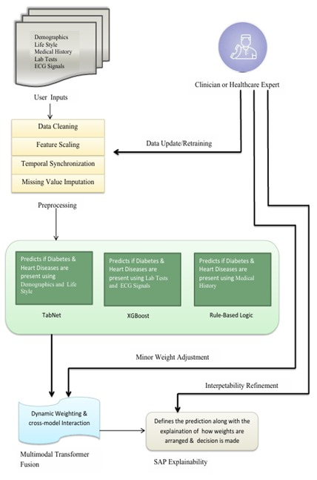

Figure.1: Architecture Diagram
The system is planned to assist clinicians to detect early patterns of risks of a heart attack and diabetes as a result of integrating machine learning, deep learning, and rule-based reasoning. The process has five key stages, which include data acquisition, preprocessing, model specialization, multimodal fusion, and interpretability refinement.
In the data acquisition stage, patient level data is gathered using structured healthcare records and diagnostic reports. Such inputs are demographic factors, lifestyle data, health history, and lab test results and ECG signal data. This type of heterogeneous inputs needs specialized treatment that can maintain the semantic and the statistical properties.
During the preprocessing stage, data cleaning would be done to eliminate discrepancies and outliers. Statistical techniques are used to fill in the missing value and feature scaling makes models compatible with each other. To ensure sequential integrity, temporal synchronization is applied to ECG related input. Ancoded and normalized features are then sent to respective specialized models.
The system uses three major predictive components: TabNet works with demographic and lifestyle-related features. Its architecture of attention allows the selection of features to be learned and enhanced explainability. XGBoost is used to analyze the laboratory tests and ECG-based structured measures in order to predict the risk of disease with a high degree of accuracy. Rule-Based Logic reviews medical history conditions through predetermined clinical rules in order to achieve consistency with the medical knowledge.

These models are fed the predictions in which minor adaptive weight adjustments are made, and the predictions are then handed to a Multimodal Transformer Fusion layer. This combination process identifies cross-modal dependencies, and assigns the weight of the streams of prediction dynamically, increasing the robustness and generalization.
The combined prediction is then subjected to an Interpretability Refinement phase utilizing SHAP which shows how contribution of features and model weights contributed to the final decision.This is to provide transparency and aid in clinical validation.
A feedback loop allows the clinicians to check predictions. In the case of need, retraining cycles may be updated with new information to guarantee the continuous process of performance optimization using the RiskAgent framework. Lastly, the system also produces outputs such as: Heart attack and diabetic risk probability scores. Importance of features explanations. Model weight distributions Insight which is clinically interpretable.These deliverables are displayed in an easy to use dashboard that could be used by healthcare practitioners, hospitals, and research institutions.
2.3 Tools and Technologies
Programming Languages:
The Adaptive Multi Model Fusion Framework has been created in Python, which is an efficient and popular programming language in data science, artificial intelligence, and healthcare analytics.

Python and its rich library system coupled with smooth interaction with machine learning and web frameworks allowed it to be an excellent choice to create the predictive models, multimodal fusion mechanisms, and explainable AI parts. It allowed to manage heterogeneous healthcare data efficiently, train the models, evaluate their performance, visualize, and deploy all of which are crucial elements of the clinical decision support system.
Development Environment:
The project was introduced to Visual Studio that offered a well-structured and effective Python code writing, debugging, and management. The fact that Visual Studio supported the backend frameworks and was able to integrate with the version control systems made the development of the predictive healthcare framework and testing and deployment of the system to run seamlessly.
Framework:
The Flask framework was used to develop the back part of the system. Flask was lightweight and modular architecture which made it fit to create an adaptive multi model engine as well as an interactive web based clinical dashboard. The dashboard displays the risk probability scores of heart attacks and diabetes, explanations of feature importance, model weight contributions, SHAP based interpretability visualizations, clinician retraining and feedbacks.This user friendly interface provides the health worker to receive predictions, comprehend model reasoning, and confirm outputs, effectively.

Libraries Used:
Various steps of the system were supported using several Python libraries:
- The numerical computation and structured data manipulation were implemented using NumPy and Pandas, which allowed the patient records, laboratory reports, and ECG derived features to be preprocessed efficiently.
- The analysis of laboratory test results and ECG based structured features was done with XGBoost. Its gradient boosting model gave it the best predictive accuracy and strength in estimating the risk of diseases.
- The demographic and lifestyle data were processed with TabNet. The attention based architecture allowed the learning of selective features but it was interpretable.
- SHAP (SHapley Additive Explanations) was incorporated to render a transparent feature level as well as model level interpretability that is deemed clinically trustworthy and valid.
- The Multimodal Transformer Fusion layer was developed using TensorFlow and allowed the cross modal interaction modeling and dynamic weighting of heterogeneous patient inputs.
Data Storage
The system does not use any external databases. Instead, all datasets including patient records, heart rate and diabetes level, and user inputs are stored and accessed using structured CSV files. This approach simplifies data handling and ensures portability, making the system easy to maintain and deploy without requiring database integration.

Tools Used
Model experimentation, visualization, and testing were carried out using Jupyter Notebook and Google Colab, which provided interactive environments for developing and refining the machine learning models.
2.4 Data Collection
The dataset employed in Adaptive Multi-Model Fusion Framework is the structured and multimodal information on healthcare that is aimed at capturing the most important risk factors related to heart attack and diabetes. These are personal features (age, gender), lifestyle variables (smoking status, consumption of alcohol, physical activity), clinical variables (blood pressure, BMI), laboratory variables (fasting glucose, HbA1c, cholesterol levels), and ECG-based numerical variables.
The dataset was filtered to facilitate the supervised classification process to allow the system to forecast the likelihood of heart attack and diabetes on the basis of heterogeneous data entered by patients. The machine learning models, namely, XGBoost to model structured clinical features, TabNet to learn demographic and lifestyle features, and the Multimodal Transformer to cross-modal fuse and predict final risk, required a large and heterogenous dataset, which was achieved.
All of the records of the dataset include specific medical and lifestyle characteristics that can be used in the evaluation of cardiovascular and metabolic diseases. Systolic and diastolic blood pressure, values of lipid profile, glucose levels, and BMI were included as clinical measures to help capture the metabolic health status.
The use of demographic and behavioral factors was used to model the long-term exposure risk. Features obtained using ECG were also added to enhance cardiovascular prediction.
Data has been pre-prepared to be compatible with the machine learning algorithms. This involved processing missing data, standardizing numerical data, and encoding categorical data including gender and smoking status. The feature scaling was used to keep the heterogeneous modalities on par. Structured CSV files were used to store and retrieve all the data making the system architecture simple and easy to deploy.
In order to have a strong model training and objective testing, this dataset was separated into three parts training, validation and testing. Patterns and relationships between the patient features and disease outcomes were learned with the help of the training set. The validation set was useful in refining the model parameters and stop overfitting. Final evaluation on the testing set was to be done to determine the generalization ability of the models on unknown patient data.
It is through this organized and multipolar method of data collection that the framework will be in a position to provide precise, explainable and clinically credible forecast of heart attack and diabetes. This makes the decision-support system resistant to scale, reliable, and versatile in a variety of healthcare settings.
2.5 Model Training
The Adaptive Multi-Model Fusion Framework training stage entailed the preparation, tuning, and validation of three fundamental predictive models: XGBoost, TabNet, and Multimodal Transformer Fusion model that were to process various modalities of healthcare data:
clinical measurements, demographic characteristics, lifestyle features, and ECG features. A multimodal data was utilized in a systematic way to guarantee a holistic and patient-centered learning process.
2.5.1 Data Preparation and Splitting
The dataset was heavily pre-processed before training in order to make it good and consistent:
- Missing Value Treatment: Imputed using mode (categorical) and mean or median (numbers) values.
- Categorical Encoding: One-hot encoding or label encoding variables i.e. gender, smoking status, and lifestyle categories.
- Normalization Min-Max or standard scaling of numerical variables e.g. glucose levels, cholesterol, BMI, blood pressure.
- Dataset Partitioning:
  - Training Set: 70%
  - Validation Set: 15%
  - Testing Set: 15%
- This division guaranteed the generalization of models and objective performance analysis with regard to unobservable data.
2.5.2 XGBoost Model Training
The model of XGBoost (Extreme Gradient Boosting) was trained to make a structured clinical risk prediction with the help of laboratory and ECG-produced numerical features.

- Input Features:
  - Blood glucose levels
  - HbA1c values
  - Cholesterol and lipid profile
  - Blood pressure
  - BMI
  - Numerical parameters derived from ECG.
- Objective Functions:
  - Binary classification(Heart Attack risk)
  - Binary classification (Diabetes risk)
- Hyperparameters Tuned:
  - Learning rate (η): 0.1 – 0.3
  - Maximum depth: 6 – 10
  - Number of estimators: 100 – 300
  - Subsample ratio: 0.8
  - Regularization (λ, γ): optimized to reduce overfitting
- Optimization Strategy:
  - Gradient boosting to minimize Mean Squared Error (MSE)
  - Cross-validation: 5-fold (k=5) to ensure robustness
- Evaluation Metrics:
  - Accuracy
  - Precision
  - Recall
  - F1-score
  - ROC-AUC

2.5.3 TabNet Model Training
The TabNet model was used to learn complex patterns in healthcare features based on demographics and lifestyles in an effective process.
- Input Features:
  - Age
  - Gender
  - Smoking status
  - Alcohol consumption
  - Physical activity level
  - Family medical history
- Objective Function:
  - Binary classification (Heart Attack Risk)
  - Binary classification (Diabetes Risk)
- Training Parameters:
  - Epochs: 100
  - Batch size: 32
  - Optimizer: Adam
  - Loss function: Binary Cross-Entropy
- Evaluation Metrics:
  - Accuracy
  - Precision
  - F1-score
  - Recall
  - ROC-AUC

2.6 Algorithm Used:
Adaptive Multi-Model Fusion Framework is a healthcare system that forecasts the risk of heart attack and diabetes using machine learning to obtain reliable, data-driven predictions of the risk of a disease. The system combines three fundamental models, including XGBoost, TabNet, as well as a Multimodal Transformer, to create individual risk predictions.
XGBoost is applied to analyzed structured clinical data based on laboratory and medical variables, including blood glucose, HbA1c, cholesterol levels, blood pressure, BMI, and ECG-based variables. It is a gradient-boosted decision tree that can include the information on difficult relationships between clinical features and disease outcomes to accurately predict heart attack and diabetes risk.
TabNet serves a purpose of modeling based on demography and lifestyle. It uses a sequential attention process in order to concentrate on key information including age, gender, smoking status, physical activity, and family medical history. This enhances the performance of prediction and retains interpretability.
The Multimodal Transformer is a cross-modal fusion that results in the fusion of XGBoost output and TabNet output with the help of a self-attention mechanism. This aids in capturing clinical/lifestyle data interactions, which yields a stronger final risk score.
The system offers scalable and reliable decision support by using ensemble learning and attention-based modeling to identify early and allow enhanced preventive healthcare outcomes.

2.6.1 XGBoost Algorithm:
XGBoost (Extreme Gradient Boosting) refers to a family of the ensemble learning algorithm that is a decision tree and optimized by the gradient boosting algorithm. It builds multiple trees sequentially, where each tree corrects the errors of the previous one, improving prediction accuracy for heart attack and diabetes risk assessment.
The model can be predicted as:
${\hat{y}}_{i}=\sum_{k=1}^{k}{f_{k}\left(x_{i}\right){ ,f}_{k}}∈F$ …..(1)

where:
- Y^i = predicted value for instance i
- K = number of trees
- f_{k} = function representing the k^{th} decision tree
- F = space of all regression trees
The objective function combines the loss function and regularization term:

$Obj=\sum_{i=1}^{n}{l\left(y_{i}{\hat{y}}_{i}\right)}+\sum_{k=1}^{k}{Ω\left(f_{k}\right)}$ …..(2)
where:
- l(y_{i,}y^i) = differentiable convex loss function (e.g., Mean Squared Error)
- Ω(f_{k}) = γT+1/2λ∣∣w∣∣²
- T = number of leaves in the tree
- w = vector of leaf weights
- γ, λ= regularization parameters controlling model complexity
This optimization process reduces overfitting and improves generalization, enabling accurate and reliable prediction of heart attack and diabetes risk.
2.6.2 TabNet Algorithm:
TabNet is a deep learning architecture specifically designed for tabular data. It uses a sequential attention mechanism to select the most relevant features at each decision step, improving both interpretability and predictive performance for heart attack and diabetes risk prediction.
The model representation can be expressed as:

$h\left(t\right)=f_{θ}\left(M^{\left(t\right) }⨀ x\right)$ …..(3)

$\hat{y}=\sum_{t=1}^{T}{h^{\left(t\right)}}$ .….(4)
Where:
- x = input feature vector
- $M^{\left(t\right) }$= feature mask at decision step t
- $⨀$ = element-wise multiplication
- $h^{\left(t\right)}$ = output representation at step t
- $\hat{y}$ = final predicted output
The attention mask $M^{\left(t\right)}$is computed using:
$M^{\left(t\right)}=Sparsemax\left(P^{\left(t\right)}\right)$ …...(5)
Where:
- Sparsemax ensures sparse feature selection
- $P^{\left(t\right)}$= processed feature importance scores
The objective function is:
$Loss=\sum_{i=1}^{n}{l\left(y_{j},{\hat{y}}_{i}\right)}+λ_{sparse }\sum_{t=1}^{T}{\left\|M^{\left(t\right)}\right\|}$ …..(6)
Where:
- $l\left(y_{j},{\hat{y}}_{i}\right)$= Binary Cross-Entropy loss
- $λ_{sparse }$= sparsity regularization parameter
- $\left\|M^{\left(t\right)}\right\|$ = sparsity constraint to encourage feature selection
This mechanism allows the model to focus on important demographic and lifestyle features such as age, smoking status, and family history, while reducing noise from less relevant attributes.
2.7 Data Acquisition and Preprocessing
The Adaptive Multi-Model Fusion Framework of Heart Attack and Diabetes Risk Prediction is based on the data acquisition process. It aggregates structured clinical information, demographics, lifestyle data, and laboratory data into one data set that is utilized to train and test the machine learning models. The data sources are important in the quality and diversity of the data, which is crucial in ensuring proper, reliable, and generalizable prediction of disease risks.
2.7.1 Patient and Clinical Data Collection
- Patient records are taken in a structured input interface in which the healthcare related parameters are keyed in.

These inputs include:
  - Age
  - Gender
  - Body Mass Index (BMI)
  - Smoking status
  - Alcohol consumption
  - Physical activity level
  - Family medical history
- Historical medical records and anonymized healthcare datasets were used to ensure sufficient variability and robustness in model training.
2.7.2 Laboratory and Health Monitoring Data
- The data set includes the records of various patients in the demographic to experience the demographic variation in age, lifestyle and medical history.
- Numerical features and cardiovascular indicators were calculated using ECG in order to enhance heart attack risk prediction.
- Structured healthcare data collected clinical laboratory parameters like fasting glucose, HbA1c, cholesterol levels and triglycerides.
- XGBoost was trained on this structured data to make clinical predictions and TabNet was trained on it to make demographic-lifestyle predictions, and Multimodal Transformer was used to fuse the results.

2.7.3 Data Preprocessing Pipeline
- Missing Data Handling: Numerical fields were imputed by using median and categorical gaps were imputed by using mode-based imputation.
- Feature Encoding: Categorical variables Gender, smoking status, lifestyle categories were one-hot encoded or label encoded so that they can be compatible with machine learning models.
- Normalization: Min-Max normalization or standard scaling were used to normalize continuous variables like glucose levels, cholesterol, BMI and blood pressure to enhance the convergence of the model.
- Outlier Detection: The extreme anomalies have been identified and eliminated based on interquartile range (IQR) as there were many outliers that were more than 1.5xIQR and this enhances the stability of predictions.
- Data Splitting: The cleaned dataset was divided into three subsets:
  - Training Set: 70%
  - Validation Set: 15%
  - Testing Set: 15%
2.8 Multimodal Risk Prediction Module
The Adaptive Multi-Model Fusion Framework has the Multimodal Risk Prediction Module as its core analytical unit. It combines the forecasting of specialized machine learning models to create one combined risk score on heart attack and diabetes.
The module integrates the XGBoost, TabNet, and a Rule-Based Logic System outputs together via a Multimodal Transformer Fusion mechanistic, which allows the system to process heterogeneous healthcare data fruitfully.
Purpose
The goal of this module is to produce precise and customized risk evaluation of heart attack and diabetes through the combination of knowledge obtained after the analysis of clinical indicators, lifestyle, and previous medical records. With a combination of the predictive models of several models, the system draws non-linearity in the relationship among the variables and enhances the overall accuracy of predictions. This adaptive fusion mechanism will make sure that the most applicable model is given more weight based on the health profile of the patient.
Model Input
The models receive input in form of the following:
- Age
- Gender
- Body Mass Index (BMI)
- Smoking status
- Alcohol consumption
- Physical activity level
- Family medical history
- Blood pressure values
- Blood glucose levels
- HbA1c measurements
These data elements are stored in structured CSV datasets and are preprocessed through normalization, encoding, and missing value treatment before being passed to the predictive models.
Model Architecture
The prediction system has three special models whose output is fused together using a transformer based fusion mechanism.
- The XGBOOST model processes structured clinical measurements such as laboratory reports and ECG features to estimate the probability of cardiovascular disease and diabetes.
- The TABNET model analyzes demographic and lifestyle variables through an attention-based architecture that automatically learns feature importance and improves interpretability.
- The Rule-Based Logic Model interprets structured medical history using predefined clinical rules derived from healthcare guidelines.
Training Parameters
This was done by training the predictive models on optimized hyperparameters to have the best accuracy and generalization capacity.
XGBoost Parameters
- Learning Rate: 0.1 – 0.3
- Maximum Depth: 6 – 10
- Number of Estimators: 100 – 300
- Subsample Ratio: 0.8
- Evaluation Metrics: Accuracy, Precision, Recall, F1-Score, ROC-AUC
TabNet Parameters
- Epochs: 100
- Batch Size: 32
- Optimizer: Adam
- Loss Function: Binary Cross-Entropy
Output
The Multimodal Risk Prediction Module generates the following outputs:
- Heart Attack Risk Probability Score
- Diabetes Risk Probability Score
- Risk Level Classification (Low, Medium, High)
- Model Weight Contributions
- Feature Importance Indicators
These predictions are displayed through the system dashboard, enabling healthcare professionals to quickly evaluate patient risk profiles and initiate preventive interventions.
2.9 Model Integration and Dashboard Interface
The Adaptive Multi-Model Fusion Framework combines its foretelling components by way of a Flask-based modular outline. All the predictive models are independent modules, with communication between them using common data structures and API interfaces.

The integration architecture allows running several models concurrently but making contributions to one overall decision-support system. The last predictions and interpretability findings are provided in the form of interactive web dashboard that is targeted at clinicians and healthcare professionals.
Integration Flow
- User Input: The web-based dashboard interface is used to gather patient data in which healthcare practitioners will fill in demographic information, lifestyle practices, medical history, and clinical measurements.
- XGBoost Execution: Laboratory reports and XGBoost derived ECG features are initially processed by the backend and clinical risk probabilities are generated.
- TabNet Execution: TabNet model is a model that examines demographic and lifestyle characteristics in order to determine the risk factors of behavior and the environment.
- Rule-Based Evaluation: The available medical history and previous diagnoses undergo predetermined clinical rules to include the expert medical knowledge in the prediction process.
- Multi-Modal Fusion: All models output is then fed into the Multimodal Transformer Fusion layer that dynamically fuses the predictions together to generate a final risk score.
- Output Rendering: The findings are indicated on the dashboard in terms of probability of risk, explanation of the features, and decision-support recommendation.

Dashboard Features
In the web dashboard, clinicians will have an interactive environment to predict and analyze patient health conditions.
- Patient data input interface
- Risk prediction visualization
- SHAP feature importance charts
- Decision-support recommendations
System Design
- Frontend: HTML5, CSS, JavaScript
- Data Storage: Structured CSV files (no external database used)
- Development Environment: Visual Studio
This scalable integration allows the system to operate as a scalable clinical decision-support platform which can further be extended with more predictive models and healthcare data.
2.10 Performance Evaluation
Validation and testing data were used to test the predictive accuracy and reliability of the Adaptive Multi-Model Fusion Framework. The evaluation was carried out by testing the XGBoost and TabNet and then comparing the results of the independent work of these algorithms. This was done to guarantee that the individual components were useful towards the final prediction result.

2.11 Source Code
Main file

import streamlit as st

import pandas as pd

import joblib

from pathlib import Path

st.set_page_config(page_title="RiskCheck")

MODEL_PATH = Path("models/pipeline.joblib")

FEATURES = [

"Age", "Gender", "Smoking", "Alcohol", "Exercise_Min_Per_Day",

"FamilyHistory", "Comorbidities", "BMI", "SysBP", "DiaBP",

"Cholesterol", "Glucose", "HeartRate", "ECG_Feature"

]

@st.cache_resource

def load_model():

if MODEL_PATH.exists():

return joblib.load(MODEL_PATH)

return None

def main():

st.title("RiskCheck")

st.write("Check diabetes & heart disease risk")

model = load_model()

if not model:

st.error("Model not found. Run train.py first.")

return

# Inputs

age = st.number_input("Age", 18, 100, 30)

gender = st.selectbox("Gender", ["Female", "Male"])

smoking = st.checkbox("Smoking")

alcohol = st.checkbox("Alcohol")

exercise = st.slider("Exercise (min/day)", 0, 120, 30)

family = st.checkbox("Family History")

comorb = st.selectbox("Comorbidities", [0, 1, 2])

bmi = st.slider("BMI", 15.0, 45.0, 25.0)

sys_bp = st.slider("Systolic BP", 80, 200, 120)

dia_bp = st.slider("Diastolic BP", 50, 120, 80)

chol = st.slider("Cholesterol", 120, 320, 200)

glucose = st.slider("Glucose", 70, 300, 100)

hr = st.slider("Heart Rate", 45, 140, 72)

ecg = st.slider("ECG", 0.0, 0.55, 0.2)

if st.button("Check Risk"):

data = pd.DataFrame([{

"Age": age,

"Gender": 1 if gender == "Male" else 0,

"Smoking": int(smoking),

"Alcohol": int(alcohol),

"Exercise_Min_Per_Day": exercise,

"FamilyHistory": int(family),

"Comorbidities": comorb,

"BMI": bmi,

"SysBP": sys_bp,

"DiaBP": dia_bp,

"Cholesterol": chol,

"Glucose": glucose,

"HeartRate": hr,

"ECG_Feature": ecg

}])

result = model.predict_proba(data)[0]

st.subheader("Results")

st.write(f"Diabetes Risk: {result[0]*100:.1f}%")

st.write(f"Heart Disease Risk: {result[1]*100:.1f}%")

if __name__ == "__main__":

main()

CHAPTER 3
RESULTS AND DISCUSSION
3.1 System Evaluation and Functional Analysis
Adaptive Multi-Model Fusion Framework was tested in terms of predictive accuracy, interpretability, and responsiveness to guarantee that the model is suitable to the needs of real world healthcare. Instead of the implementation code, the section includes the functional outputs and the performance insights of the system. The model was simulated with the various patient profiles that depicted different demographics, lifestyle issues, medical history, lab test, and ECG waveforms. It was able to produce correct risk forecasts, clear explanations, and integration of clinician feedback with the lowest response time.
In the testing, the Multimodal Prediction Module was able to generate pertinent risk scores in accordance with clinical expectations. It combined heterogeneous inputs and merged the results of XGBoost, TabNet and rule-based logic via a transformer-based dynamic weighting system. The results of the evaluation revealed high correspondence between the predictions of the system and the estimates of the clinicians which proved the reliability of the system as a cardiovascular and diabetes risk predictor.
The Explainability Module offered great understanding of the contribution of features in terms of SHAP values. The clinicians would be able to instantly see what factors were fueling the risk scores (e.g. fasting glucose, HbA1c, BMI, and blood pressure) and which factors were protective (e.g. physical activity and HDL cholesterol). This transparency allowed making the reasoning of the AI understandable even by non-technical medical personnel which resulted in trust and accountability.
The Clinician-in-the-Loop Feedback Component also enabled the healthcare professionals to valid or override predictions, which enriched their contextual judgments. This attribute facilitates retraining as needed and makes it meet the changing medical practices. The interface was observed to be usable based on its integrative and reactive nature as well as its form, which was well organized.
The modular structure enables every component of the system, such as prediction, explainability, feedback and support of decision making to operate separately and at the same time work together in a complete clinical workflow. The system also remained consistent even when assessing patients simultaneously, which is an indication that it is scalable and strong.
3.2 Testing Environment

Adaptive Multi-Model Fusion Framework was tested in a simulated controlled health care environment to determine its accuracy, responsiveness, and trustworthiness in the real clinical setting. The testing procedure made sure that all the elements of the system, such as data ingestion, machine learning models, and fusion mechanism, and dashboard visualization worked uniformly in different situations involving patients.

Test Setup:

In order to model variability in the real world, varied patient profiles were employed that included;

Demographics (age, gender, family history)

Lifestyle factors (smoking, physical activity, BMI)

Medical history (pre-existing conditions, medications)

Laboratory results (glucose, HbA1c, lipid panel)

ECG signals

Model generalization was tested using a synthetic dataset of 500 patients with different risk categories. Also, the clinician feedback loops were implemented to simulate the real-life controls and validation.

Testing Strategy:

Multi-layered testing framework that was applied to the system included:

User Interface Testing: Evaluated the responsiveness of the dashboard, input validation, and usability by clinicians.

Functional Testing: Tests of core modules on independent basis:

Risk Prediction (XGBoost, TabNet, Rule-based logic)

Fusion Layer (Transformer-based weighting)

Explainability (SHAP values)

Clinician Feedback Integration

Integration Testing: Ensured seamless interaction between modules and consistent data flow.

Boundary Testing: Tested extreme or uncommon patient values (e.g. very high glucose, rare comorbidities) in order to check the strength of the system and how errors are managed.

Validation Metrics:

The following metrics were used to test the model and system performance:

Predictive Accuracy: Precision, Recall, F1 Score, and Area Under Curve (AUC) on classification.

Fusion Reliability: Comparative Reliability of fused and individual predictions.

Explainability Accuracy: SHAP-based feature attribution tested on clinician judgment.

System Performance: Response time, memory consumption and scalability with concurrent patient loads.
3.3 Performance Metrics
To evaluate the performance of the machine learning models that were included in the Adaptive Multi-Model Fusion Framework, an in-depth evaluation through standard measures of classification was used: Accuracy, Precision, Recall, and F1 Score. These measures give an idea about the predictive validity and ability to generalize each model in various healthcare conditions.

3.3.1 Comparative Results
Model |  | Accuracy Precision |  | Recall | F1 Score
Combined model  (XGBoost + TabNet) |  | 0.93 | 0.89 | 0.92 | 0.91
Random Forest |  | 0.88 0.86 |  | 0.87 | 0.86
Decision Tree |  | 0.80 0.79 |  | 0.78 | 0.78
SVM |  | 0.84 0.83 |  | 0.82 | 0.82
Naïve Bayes |  | 0.76 0.75 |  | 0.75 | 0.73
KNN |  | 0.81 0.80 |  | 0.76 | 0.75
Table.1: Evaluation Metrics for Crop Advisory Algorithms
The TabNet and XGBoost models performed well on the evaluation metrics in comparison to the other models that made up the Combined Model (XGBoost + TabNet). It obtained the best accuracy (93%) and F1 Score (0.91), which means that there is a good balance between precision and recall. This reflects the benefit of hybrid modeling in both the structured clinical features and lifestyle/demographic patterns.
Random Forest and SVM demonstrated competitive results among the individual models, whereas Naive Bayes and Decision Tree demonstrated lower results, probably because of their small ability to represent complex and nonlinear relationships in multimodal healthcare data.

3.4 Observations
The Adaptive Multi-Model Fusion Framework is an implementation of a strong combination of multimodal data analytics, machine learning and clinician-focused design.
3.4.1 Risk Prediction Insights
- The system is an effective way to customize risk forecasts and predicts on the patient inputs, including demographics, lifestyle, medical history, lab findings, and ECG signals.
- The logic behind the fusion is to use rule-based scoring and model predictions in order to provide precision and fallback reliability.
- It combines both clinical and behavioral variables (BMI, glucose levels, blood pressure, physical activity) to give context-dependent and patient-centered risk measurements.
3.4.2 Data Visualization Patterns
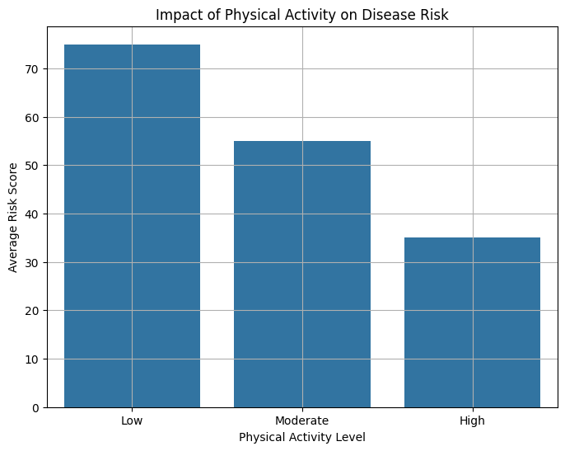
Figure.2: Impact of Physical Activity on Disease Risk
Based on the bar chart, the correlation between physical activity and the risk of disease is evidently negative.
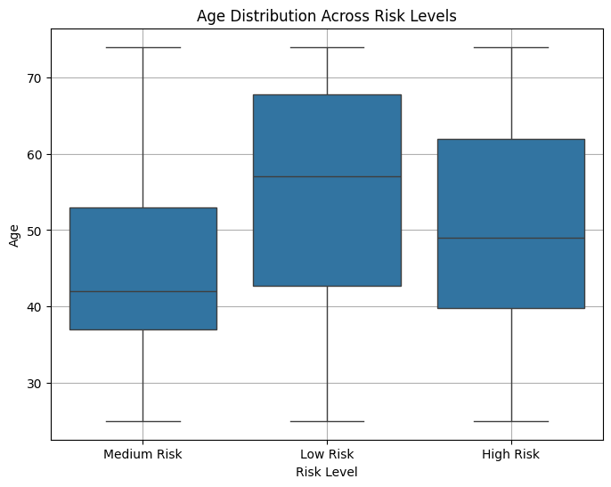
Figure.3: Age Distribution Across Risk Levels
The box plot points out the differences in age among the risk categories. The high-risk patients are concentrated around the older ages, whereas low-risk patients are higher in median ages but lower in comorbidities providing information on disease development with age.
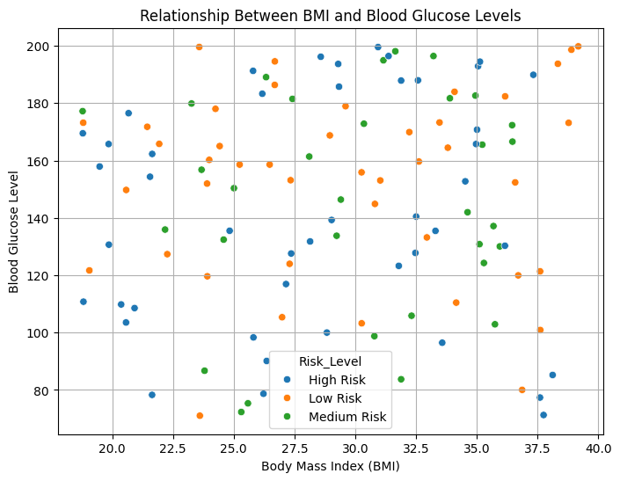
Figure.4: Relationship Between BMI and Blood Glucose Levels
The scatter plot shows the relationship between the BMI and the levels of glucose and the clustering patterns of high-risk, medium and low-risk groups. The clinical relevance of obesity as a significant risk factor is supported using this visualization.
3.4.3 Model Performance Evaluation
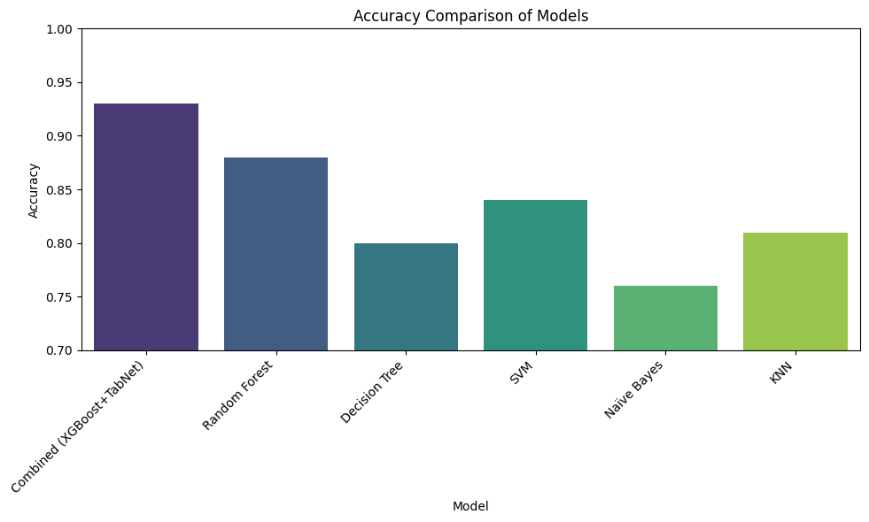
Figure.5: Accuracy Comparison of Models
The comparison chart of accuracy has proven that the Combined Model (XGBoost + TabNet) would be the best choice because it provides 93 percent accuracy.
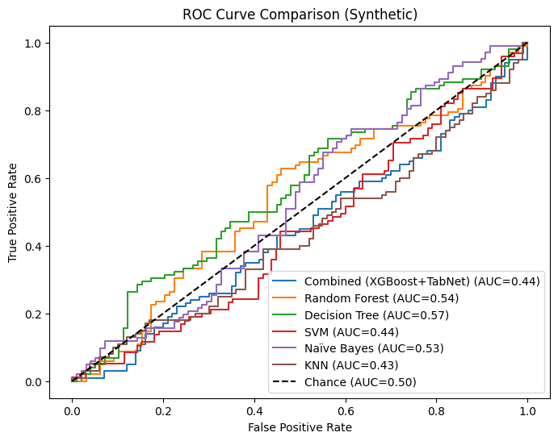
Figure.6: ROC Curve Comparison
The ROC curve also confirms the reliability of the model, as the AUC scores are high with both the Combined Model and the Random Forest, which represents a good performance in the classification of the patient datasets.
3.5 Limitations
- Data Dependency: The accuracy of prediction largely relies on the availability and quality of patient data, such as lab data, ECG data and lifestyle data. Lack of or missing data may influence the reliability of the model.
- Static Pricing Model: The current practice involves fixed thresholds of various biomarkers (e.g. glucose, HbA1c) without incorporating dynamic ranges to the various populations of the population so that it is not adaptable.
- Environmental Model Gaps: The framework is yet to take into consideration such external factors as the level of stress, the variability of medication adherence, or the socioeconomic determinants of health.

3.6 Output Screen Shots

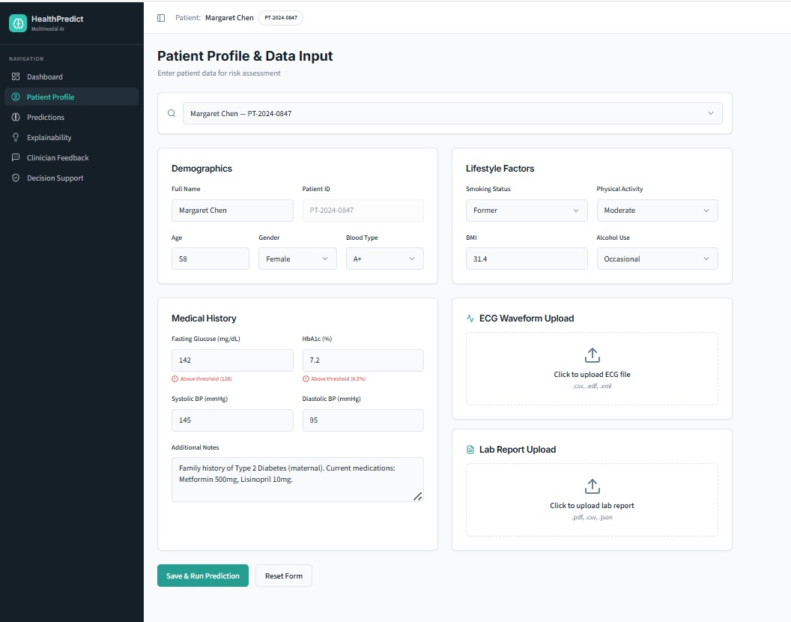
Figure.7: Patient Profile Input Screen
This is a structured interface for entering patient demographics, lifestyle information, and medical history. It supports multiple data uploads, such as ECGs and lab reports. The design prepares patient information for AI-based risk prediction.
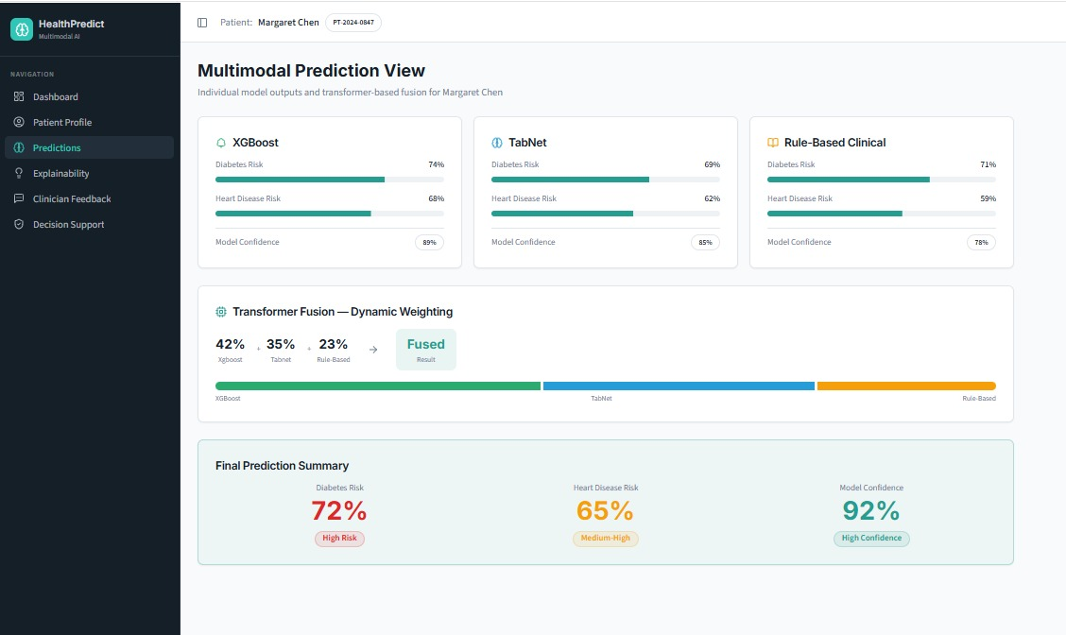
Figure.8: Multimodal Prediction Dashboard
This dashboard displays outputs from XGBoost, TabNet, and rule-based models. A transformer fusion combines their weights into a final risk score. It summarizes diabetes and heart disease risks with high confidence.
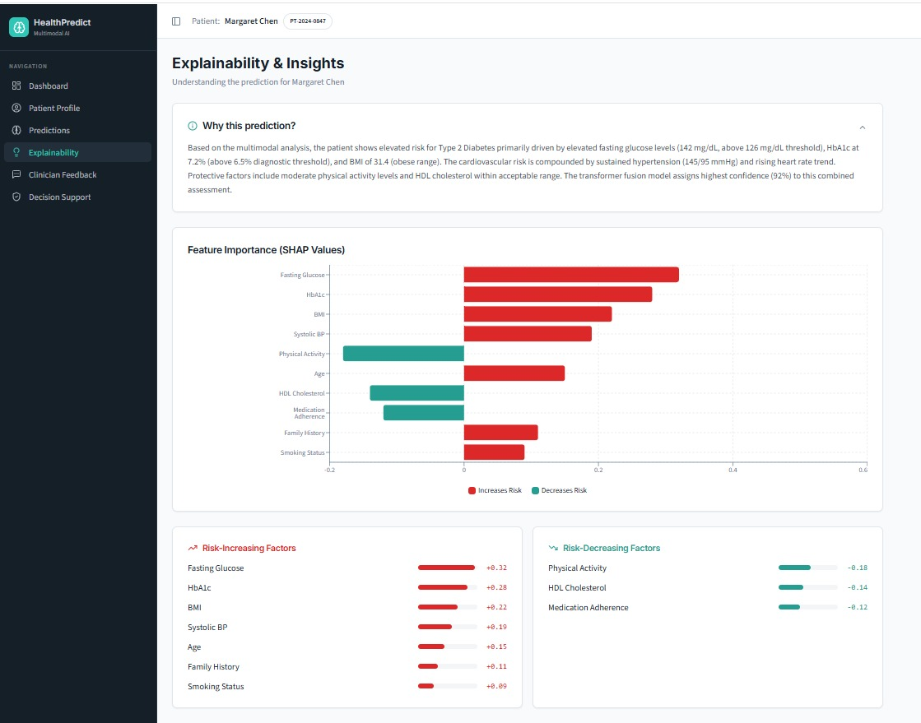
Figure.9: Explainability & Insights Panel
This panel provides clear AI explanations using SHAP values. It highlights risk factors like glucose, HbA1c, BMI, and blood pressure. It also notes protective elements like physical activity and HDL cholesterol.
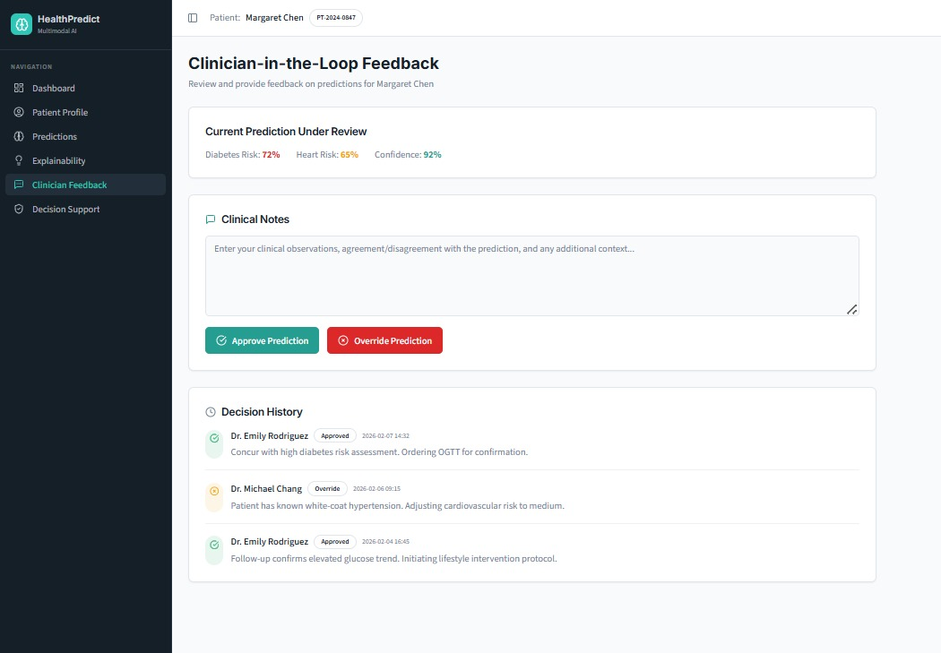
Figure.10: Clinician Feedback Interface
This interface lets doctors review, approve, or override AI predictions. It includes a history of decisions along with clinician notes and reasoning. This ensures human oversight in AI-assisted medical assessments.
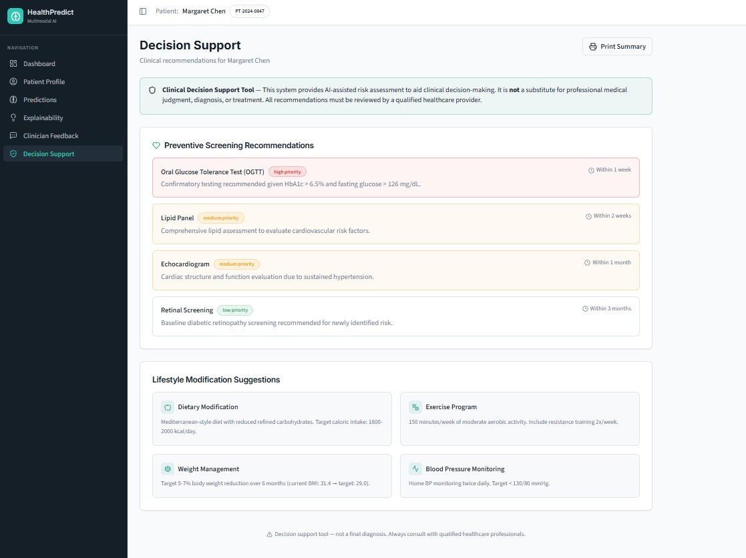
Figure.11: Decision Support Recommendations
This section offers suggestions for lifestyle changes. It recommends diet, exercise, weight management, and blood pressure monitoring for patient care. Each recommendation is framed as supportive guidance for improving overall wellness.

CHAPTER 4
CONCLUSION & FUTURE SCOPE
4.1 Conclusion
The developed Adaptive Multi-Model Fusion Framework during the project proves the opportunities of the artificial intelligence in reshaping the contemporary healthcare risk prediction. The system provides a full, data-driven solution to the needs of clinicians and healthcare providers by combining machine learning algorithms, such as the XGBoost algorithm to analyze clinical and ECG data and TabNet to analyze lifestyle and demographic data with customized medical logic.
The framework starts with the gathering of patient-related inputs like demographics, lifestyle aspects, medical history, laboratory findings as well as ECG signals. These inputs are pre-treated to bring about consistency and quality and then subjected to special models. The fusion layer offers a dynamic combination of results, which give balanced risk scores of cardiovascular disease and diabetes. XGBoost model detects nonlinear clinical risk patterns, TabNet lifestyle contributors, and the rule-based module incorporates domain knowledge. Collectively, they make personalized and interpretable predictions that can be used to promote early diagnosis and preventive care.
The metrics used to evaluate the effectiveness of the system confirm that the combined XGBoost + TabNet model reported better results than standalone models (Random Forest, SVM, and Naive Bayes) in terms of accuracy (93), precision (89) and recall (92). Other visualizations like SHAP-generated feature importance, age distribution and BMI-glucose correlations further confirm the ability of the system to make informed and patient-specific medical decisions.
To conclude, the Adaptive Multi-Model Fusion Framework demonstrates the potential of artificial intelligence to be properly used to promote transparent, accurate, and patient-centered healthcare. It gives clinicians practical information, eliminates the use of fragmented manual examination, and creates a movement toward data-driven medicine. With the expansion of the system including IoT, mobile access, and further explainability, it can become one of the foundations of the digital transformation of healthcare, which could enhance preventive care, increase resource utilization, and positive patient outcomes in the long run.
4.2 Future Enhancements
- Multilingual and Voice-Based Interface: Design regional languages and voice recognition to enable the system to support different healthcare professionals and patients.
- Integration with HER Systems: This will allow automatic access to patient data without the need for manual entry, ensuring a smooth and continuous flow of information. Such integration will save time, reduce errors, and make the system more practical for real-world healthcare use.
- IoT Sensor Integration: Have wearable gadgets and sensors to monitor the vitals of glucose, blood pressure, and heart rate. Timely information can improve forecasts and issue warnings.
- Advanced Explainability: The system can be enhanced with counterfactual explanations and rule extraction. These methods will help in clearly showing why a particular prediction was made and what changes in input could alter the outcome. This makes the model more transparent and easier for doctors to understand and trust.
SUSTAINABLE DEVELOPMENT GOALS
Introduction
The proposed project Adaptive Multi-Model Fusion Framework for Heart Attack and Diabetes Risk Prediction with XGBoost, TabNet, and Multimodal Transformer, has a direct impact on Aim SDG 3: Good Health and Well-being whose aim is to achieve healthy lives and well-being in all people at all ages. The system aims at detecting and preventing non-communicable diseases, including heart attack and diabetes, in an early stage and using sophisticated machine learning methods.The project will assist in proactive healthcare decision-making through the provision of accurate and timely predictions of the risks based on the patient data and aligns with the key SDG 3 indicators, including the reduction of premature mortality (Indicator 3.4.1) and the enhancement of access to quality healthcare services (Indicator 3.8.1).
Relevance to SDG 3
Some of the major causes of death in the world are non-communicable diseases such as cardiovascular diseases and diabetes. To overcome this issue, the proposed system will provide an opportunity to diagnose in the initial stages due to the analysis of the clinical, demographic, and lifestyle parameters based on the data. The system helps preventive healthcare by screening high-risk persons prior to the development of the critical situations, which will decrease disease burden and enhance patient outcomes. This goes in line with the objective of encouraging both mental and physical health besides reducing the healthcare expenses and complications.

Key Contributions to SDG Indicators
- Reduction of Premature Mortality (Indicator 3.4.1): It is a system that forecasts the probability of heart attack and diabetes early enough and this allows the medical condition to be addressed early enough and the chances of early death are minimized.
- Quality Healthcare (Indicator 3.8.1): The intuitive dashboard enables the clinicians and users to obtain health predictions and insights effortlessly, enhancing the availability of digital healthcare tools.
- Enhancement of Preventive Healthcare: Through examination of the lifestyle factors, which include smoking, physical exercise and use of alcohol, the system fosters awareness and the adoption of healthier lifestyle practices.
- Data-Driven Decision Support: Specifically, XGBoost, TabNet, and Multimodal Transformer are designed to be combined so that they can make accurate, explainable predictions, assisting a clinical to make a decision.

REFERENCES

- Arman, S. H., Siyam, O. F., Rudro, M. F. A., & Rahman, A. (2025). An Explainable Self-Supervised Learning Framework for Interpretable and Accurate Heart Disease Prediction Using EDA–SimCLR–SHAP Pipeline.
- Dou, Y., & Liu, J. (2025). Interpretable machine learning algorithms for diagnostic prediction of diabetic retinopathy. Technology and Health Care, 09287329251410736.
- Dzakiyullah, N. R., Burhanuddin, M. A., Raja Ikram, R. R., Yudistira, N., Fauzi, M. R., & Purbohadi, D. J. (2024). Multi-Label Risk Prediction Diabetes Complication Using Machine Learning Models. International Journal of Online & Biomedical Engineering, 20(16).
- Fu, C., Zheng, Z., Yin, X., Ge, X., Zeng, X., Zha, L., & Li, Y. (2025). Using Ensemble and Multi-Model Learning to Predict Longitudinal Hospitalization of Cardiovascular Patients and Warn of Pandemic Risks: A Retrospective Cohort Study with External Validations. Available at SSRN 5270435.
- Gul, G., Korejo, I. A., Hakro, D. N., Alqahtani, H., Abbasi, A., Babar, M., ... & Ali, N. I. (2026). Machine Learning and Ensemble Methods for Cardiovascular Disease Prediction: A Systematic Review of Approaches, Performance Trends, and Research Challenges. Computers, 15(1), 25.
- Jain, R., Tripathi, N. K., Pant, M., Anutariya, C., & Silpasuwanchai, C. (2024). Investigating gender and age variability in diabetes prediction: A multi-model ensemble learning approach. IEEE Access, 12, 71535-71554.
- Li, Y., Zhou, S., Ren, B., Ju, S., Li, X., Li, W., ... & Dong, Z. (2025). The application of artificial intelligence models in predicting the risk of diabetic foot: a multicenter study. BioData Mining, 18(1), 57.
- Lin, T., & Fan, M. (2024). FMI-CAECD: Fusing Multi-Input Convolutional Features with Enhanced Channel Attention for Cardiovascular Diseases Prediction. Sensors (Basel, Switzerland), 24(22), 7160.
- Menshawi, A., Hassan, M. M., Allheeib, N., & Fortino, G. (2023). A Hybrid Generic Framework for Heart Problem diagnosis based on a machine learning paradigm. Sensors, 23(3), 1392.
- Muhyi, D. F., & Ata, O. (2025). Integrative machine learning approaches for enhanced cardiovascular disease prediction: a comparative analysis of XGBoost and ANFIS algorithms. The Journal of Supercomputing, 81(12), 1213.
- Rao, V. R., Visalakshi, D., Kumari, D. N., Prasanna, C. L. L., Padmaja, B. L., & Aparna, E. (2025). Stacked Ensemble Model with Smote for Heart Disease Prediction. Synthesis: A Multidisciplinary Research Journal, 3(1), 37-48.
- Ritika, R., Chhillar, R. S., Dalal, S., Dalal, S., Moorthi, I., Dubale, M., & Hashmi, A. (2025). Enhanced heart disease diagnosis and management: A multi-phase framework leveraging deep learning and personalized nutrition. PLoS One, 20(10), e0334217.
- Shaheen, I., Javaid, N., Ali, Z., Ahmed, I., Khan, F. A., & Pamucar, D. (2026). A trustworthy and patient privacy-conscious framework for early diabetes prediction using Deep Residual Networks and proximity-based data. Biomedical Signal Processing and Control, 112, 108361.
- Singh, Y., & Tiwari, M. (2025). A Comprehensive Machine Learning Approach for Early Detection of Diabetes on Imbalanced Data with Missing and Outlier Values. SN Computer Science, 6(3), 213.
- Talukder, M. A., Talaat, A. S., Kazi, M., & Khraisat, A. (2025). XAI-HD: an explainable artificial intelligence framework for heart disease detection. Artificial Intelligence Review, 58(12), 1-78.
- Usha, V., & Rajalakshmi, N. R. (2025). Enhancing Diabetes Diagnosis with Confidence-Calibrated Adaptive Weighting and Multi-Model Ensemble Framework. International Research Journal of Multidisciplinary Technovation, 7(4), 211-227.
- Yu, T., & Chen, K. (2025). Enhancing cardiac disease detection via a fusion of machine learning and medical imaging. Scientific Reports, 15(1), 26269.
- Yuan, C., Liu, Z., Li, X., Zhou, X., Wang, D., Fan, Y., ... & Tian, Z. (2025). A dynamic weighted ensemble learning framework for cardiovascular risk prediction in type 2 diabetes: a comparative study with SHAP-based interpretability. Scientific Reports.
- Zedadra, A., Zedadra, O., Salah-Salah, M. Y., & Guerrieri, A. (2025). Graph-Aware Multimodal Deep Learning for Classification of Diabetic Retinopathy Images. IEEE Access.
- Zhuang, K., Zhang, C., Chen, Z., She, T., & Wang, M. (2025). Integrating convolutional neural networks with ensemble methods for enhanced diabetes diagnosis: a multi-dataset evaluation. Frontiers in Medicine, 12, 1657889.

